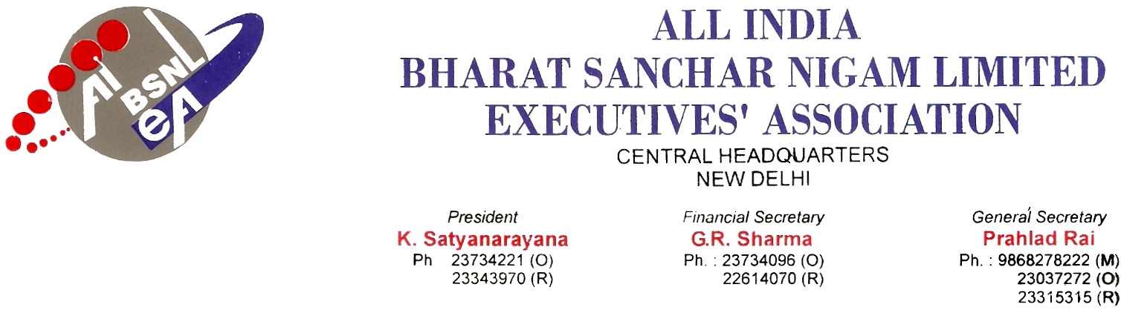

No. AIBSNLEA/CHQ/Resolution/2010 Dated 16.02.2010

Resolution

It is unanimously resolved that Shri A. Vinay kumar, JTO (Groups) Parappa, Kannur, Kerala is hereby authorized and nominated as the representative of AIBSNLEA for the purpose of contesting litigation pending in Honorable Supreme Court of India. He is further authorized to take all necessary steps for impleadment in the SLP 13220-13221 of 2009 filed by Michael P.M and others filed on 27.11.2009.

(PRAHLAD RAI)
General Secretary

