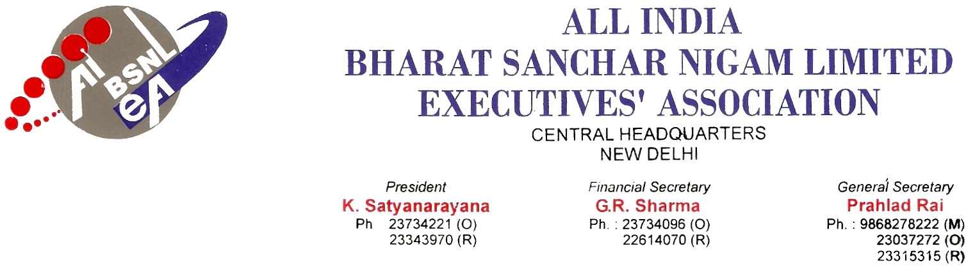

No. AIBSNLEA/CHQ/Resolution/2010 Dated 16.02.2010

Resolution

Shri Roshan Lal Matto is hereby authorized and nominated as the representative of AIBSNLEA for the purpose of contesting litigation pending in Honorable High Court of J & K. He is further authorized to take all necessary steps for vacation of interim stay granted by Honorable Court where under our promotions have been stayed.

(PRAHLAD RAI)
General Secretary

