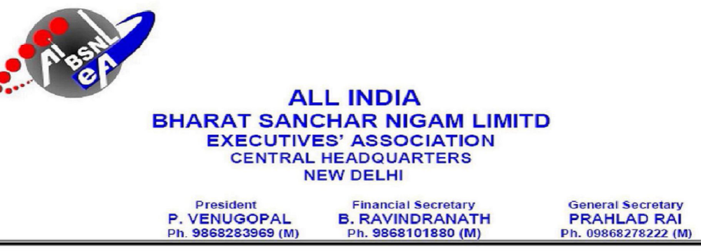
No. AIBSNLEA/CHQ/Sr.GM(Pers)/2013 DATED:04.02.2013

To
The Sr GM(Pers)
BSNL CO
NEW DELHI-110001

Sub: - Requests for correction in seniority list of SDE(T) -Reg.

Sir,

Please find herewith enclosed request applications for correction in the cadre of SDEs(T).

Sl No | Name of the officer | Present  Circle | Requested  for | Remarks
01 | Shri G R Ranganathaiah  199104708 | KTK | Wrong fixing of seniority no | Wrong fixing of seniority no in the revised seniority list for DPC SDE(T) to DGM/DE adhoc
02 | Shri Murthy R  199209035 | KTK | Wrong fixing of seniority no | Wrong fixing of seniority no in the revised seniority list for DPC SDE(T) to DGM/DE adhoc
03 | Shri M B Doddamani SDE 33414 | KTK | Wrong fixing of seniority no | Wrong fixing of seniority no in the revised seniority list for DPC SDE(T) to DGM/DE adhoc
04 | Shri P K Gopal  SDE 33415 | KTK | Wrong fixing of seniority no | Wrong fixing of seniority no in the revised seniority list for DPC SDE(T) to DGM/DE adhoc
05 | Shri N Sheshappa SDE 33417 | KTK | Wrong fixing of seniority no | Wrong fixing of seniority no in the revised seniority list for DPC SDE(T) to DGM/DE adhoc

We would therefore request you to kindly consider the above case of SDEs (T)
favourably at the earliest.

Thanking you,
Yours Sincerely
-Sd- (Prahlad Rai)
General Secretary

