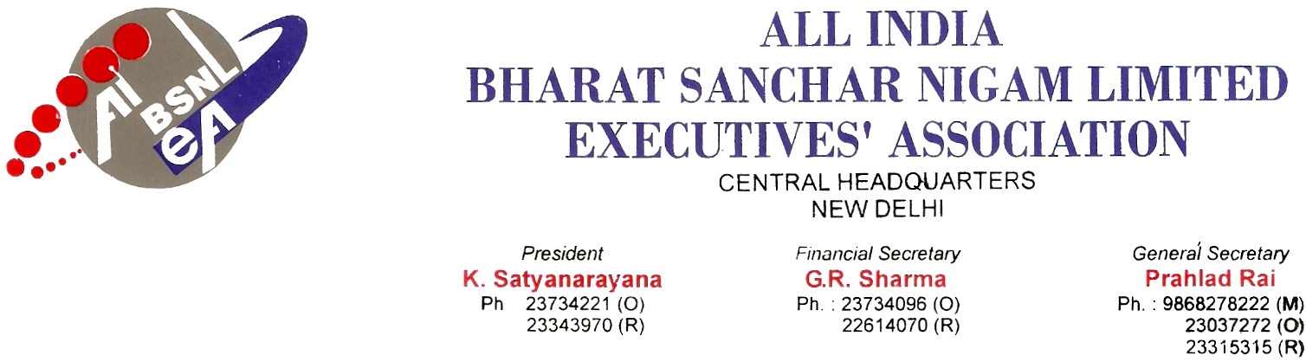
No. AIBSNLEA/CHQ/GM(Pers)/2010 DATED 04.02.2010
To,
The GM (Pers)
BSNL CO
NEW DELHI-110001.
Sub: Request for transfer in the cadre of SDE (T)-Reg.
Sir,
Please find herewith enclosed request applications for transfer in the cadre of SDE(T) as under :

SlNo. | Name of the officer | Present Circle | Requested for | Remarks
1 | Sh. K. Srinivasa Rao Staff No-17671HR-198002955 | AP | AP | Request for cancellation of transfer
2 | Sh. Udayanath Sahu,  Sr. SDE Staff No-33333 HRMS NO-197303856 | ETR | Orissa | Requested for transfer on promotion
3 | Smt. Leela H. N, SDE  HRMS No- 199704461 | QA | KTK | Request for transfer
4 | Sh. K. Vaithyanathan,  Sr. SDE Staff No-16141 | Chennai | Chennai | Request for cancellation of transfer to J&K
6 | Sh. P.Chandrasekaran, SDE Staff No-34073 | Chennai | Chennai | Request for transfer on promotion
We, would therefore request you to kindly consider the requests for transfer in the cadre of SDEs(T) at the earliest date.

Thanking you, Yours Sincerely,

Sd/-
(Prahlad Rai) General Secretary

