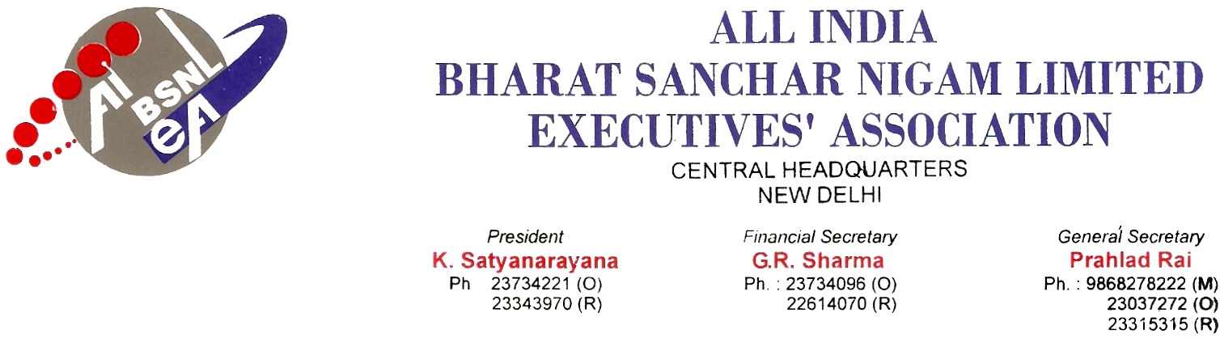
No. AIBSNLEA/CHQ/GM(Pers)/2010 DATED 04.02.2010
To,
The Director (HR)
BSNL
NEW DELHI-110001.

Sub: Request for cancellation of transfer in the cadre of DE-Reg.

Sir,

Please find herewith enclosed request application for transfer in cadre of DE as under :

SlNo. | Name of the officer | Present Circle | Tfd to | Remarks
1 | Sh. Shivdan Meena, DET Staff No.-13790 HRMS No-198503599 | Raj | J & K | Request for cancellation of transfer on medical ground
We therefore request you to kindly consider the request for transfer in the cadre of DE at the earliest.
Thanking you, Yours Sincerely,
Sd/-
(Prahlad Rai) General Secretary

