No: AIBSNLEA/CHQ/TFR/2008 Dated: 24-10-2008

To
The PGM (FP)
Bharat Sanchar Nigam Limited
New Delhi – 110001

Sub: Regarding consideration of requests for Inter-Circle transfers in the cadres of CAOs/AOs/AAOs/JAOs –Reg.

Sir,

Kindly find enclosed herewith the request applications for Inter-Circle transfers of CAOs/AOs/AAOs/JAOs. The particulars of officers are as under :
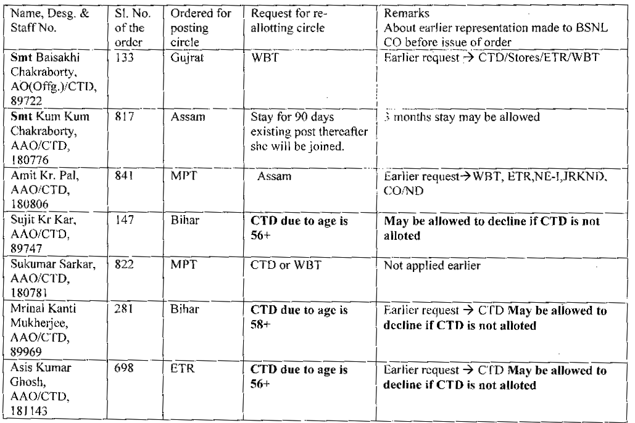
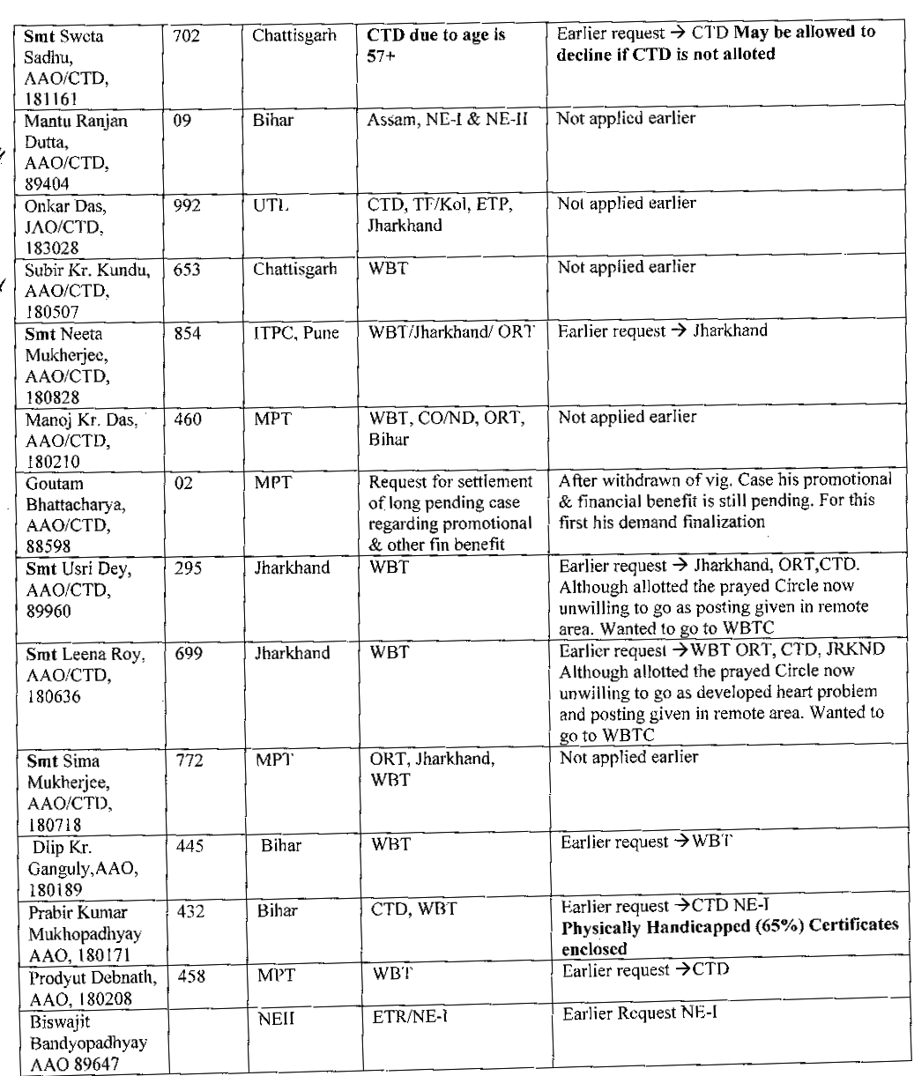
We would therefore, request you to consider above mentioned cases of request transfers at the earliest.
Yours sincerely,

(Prahlad Rai)
General Secretary

