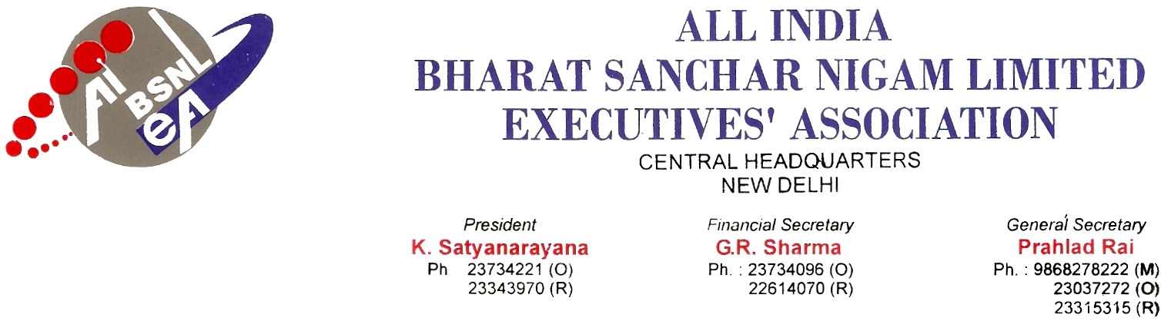
No: AIBSNLEA/CHQ/CMD/2010 Dated: 1ST Feb 2010
To
Shri Kuldeep Goyal
Chairman cum Managing Director
BSNL
New Delhi.110 001

Sub: Settlement of the long pending issues of Telecom Factories-Reg.
Respected sir,
We constraint to bring to your kind notice on the above referred subject, the following issues has been elaborated and lettered to you frequently even thought these issues are not settled.
- One time up-gradation /consideration thereof, of the qualified JTO(TFs) waiting since 1990.
- DPC to be conducted to fill up vacant post of SDE(TFs) from JTOs regularly for both the quota(i.e. 67% and as well as 33%). No competitive examination is conducted as per new RR but at the same time 09 Nos of posts of SDE(TFs) have been filled up.
- Implementation of Lateral Advancement Scheme to TFs (JTO’s pay scale was approved in 1999 by the then Parliamentary Committee and upgraded in file but not implemented.)
- Consideration of up-gradation of 30 posts of AMs(JTS) to AGM(STS).
- Regularization of local officiating promotion of Shri T Radhakrishnan (Personal Officer) who is officiating since last six years.
- Issues regarding creation of post of PPS, Counting of residency period and promotion avenues for PS in BSNL.
- Up-gradation of Pay scale of the post of Hindi Adhikari (AD(OL)) in Telecom Factory.
- Implementation of IDA pay scale from 01.10.2000.

We, would therefore request you to kindly intervene in the matter so that the above cases are settled at the earliest.

With kind regards, Yours Sincerely,
Sd/-
(Prahlad Rai) General Secretary

