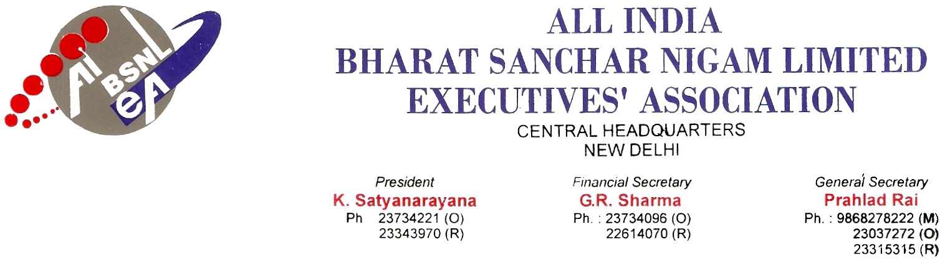
No. : AIBSNLEA/CHQ/Dir (HR)/2010 Dated 09.02.2010

To,
Shri Gopal Das
Director (HR)
BSNL
NEW DELHI.

Sub: Furnishing of long stay list in respect of SDEs- reg.
Ref : No. 1-3l2009-Pers.ll dated January 29 , 2010.

Respected Sir,
We would like to bring to your kind notice on the above subject matter under reference, the long stay list in respect of top 20 SDEs(Telecom),who are of less than 55 years of age as on 31.3.2010 with reference to the stay counted from the grade of JTO onwards was called for from all the Telecom Circles, for the purpose of transfer.
As per BSNL’s Employees Transfer Policy No. 6-1/2007-Restg. Dated 7th May, 2008, Section C Para 12 (i) “In case of executives of non-territorial circles, posting within territorial jurisdiction of recruiting circle shall be counted towards stay tenure purpose.”
In this context, we request you to kindly consider the territorial seniority for the purpose of transfer by preparing the seniority list from the Circles including Telecom Circle and other units like QA, STR, STP, WTR, WTP, Inspection unit (T&D) etc. So that uniformity may be maintained in the seniority for transfer purpose.
With regards, Yours Sincerely,
Sd/-
(Prahlad Rai)
General Secretary
Copy to: Shri R K Mishra, GM (Pers), BSNL CO, New Delhi.

