No. AIBSNLEA/CHQ/CMD/2008 Dated: 23-04-2008

To,
Shri Kuldeep Goyal,
Chairman-cum-Managing Director,
BSNL, New Delhi-110001

Sub: - New Proposals on tariff plans to increase the base of Landline & GSM customers-reg.
Sir,
As you know, BSNL is facing contineous surrender of Landline telephone connections and reduction of GSM customers due to non-competitive tariff plans with other service providers. To increase the customer base of Landline and GSM connections in BSNL, we are submitting some new proposals on tariff plans as under:-

1. For Rural subscribers with Rs. 50/- rent we may have Life time scheme as follows-

- Registration charges Rs.500/-
- talk time Rs.50/- p.m. for six months i.e., 50 free calls per month.

- pay Rs.200/- every six months (after the first six months which are covered under entry charges) or Rs.35/- p.m.
- free calls 50 p.rn. (as mentioned above)

This means the subscriber has to pay Rs.33.33 p.m. and he gets 50 free calls (in the existing scheme he pays Rs.50/- p.m. and gets 75 free calls )

- bills bimonthly

- in case the bills are not paid within one month (with penalty) after due date, the plan will have to be terminated
- call charges after free calls : Rs. 1/-

The above Life time scheme may attract rural customers and BSNL may get RHDEL subsidy.

Whether the above scheme may be offered to Rural Subs paying Rs.110/- rent p.m. has to be examined or a suitable Life time plan with higher rentals I charges may be though of for them, as given below ;

Contd page-2

-2-

* entry charges Rs.900/-
* talk time : 50 free calls p.m.
* Pay Rs.450/- every six months OR Rs.75/- p.m.
Rs.360/- Rs.60/- p.m.
(here the subs. Gets 50 free calls p.m. for rent of Rs. 75/- p.m. in the existing plan Rs.60/- p.m.
In the existing plan the sub, gets free calls for Rs.110/-).

* call charges after free calls Rs l/-

* for Urban subs also we may workout suitable Life time plans to answer retention of Land Line.

(2) For Urban Sulabh Subscribers (most of them with O/Gcalls barred), we may give 30 free calls p.m. but keep the call charges as Rs. 1.50/- after free calls. This may induce them to opt for O/G facility and make more than free calls. This will also help us to retain them. Otherwise the Excel Anant may appear to be cheaper for them.

(3) To an Urban subscriber BSNL give 50 free calls p.m. with local call duration of 3 minutes. Customers think that, 50 free calls are too less for the amount (rent) they pay. Instead of this BSNL may reduce the call duration to 1 minute and offer 150 free calls. BSNL may loose some revenue for calls of duration less than 3 min. But this will make the landline appear cheaper and help us in retaining the land line customer thus offsetting the reduction in revenue. Otherwise the decline in landlines may drastically reduce the revenue. Our present Landline revenue is almost 50% of what it was 3-4 years back. Had we taken care much in advance, we could have stabilized it 60 to 70%. Further with 1 minute call duration, we may fix the call charges at 40 paise or 50 paise per minute (with 50 paise/min, we may be able to offset the loss to some extent as a 3 minutes call will cost Rs.1. 50 instead of Rs.1. 20). The number of free calls under all plans have to be suitably worked out.

This needs to be taken up with corporate office.

(4) Family Package (Mobile and Landline)

In a family, Father, Son and Daughter have a BSNL mobile with them and there is a landline in the house for the mother, and all the three mobiles have availed 10 paise call facility to one mobile and landline (as shown below),

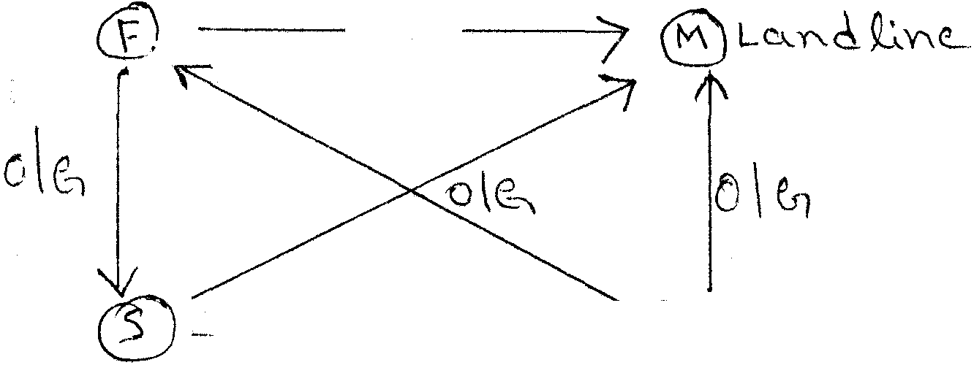

Contd page -3

-3-

All of them are able to speak to the remaining three persons for 10 paise/min. by either making O/G calls or by getting incoming calls (by giving missed calls). This is the subscriber managed arrangement. BSNL may allow an the three mobiles to make calls to any two mobiles and the landline under " Family Package" scheme by charging Rs.20/- p.m. (say) and popularize the scheme. Thus from three mobiles BSNL gets additional revenue of Rs.60/~ p.m. We may allow this facility upto 5 mobiles (for a bigger family) or more but then we may charge a higher amount of say Rs.30/- per mobile. A small office with 10 mobiles + 1 or 2 landlines will be able to use such facility and this scheme may be extended to a group of any size, such scheme is likely to be very attractive and help us in increasing / retaining market share.

(5) SMS package also required to be introduced in prepaid Excel connections similarly as introduced in postpaid connections in past months. This will attract to younger customers for which the SMS facility is charming and will help to increase our customer base.

We shall therefore, request you to kindly instruct the concern cell officers to examine the above mentioned proposals of new tariff plans and for its implementations.

With kind regards,

Yours sincerely,
(Prahlad Rai)
General Secretary

Copy to:- Shri S.D.Saxena, Director(Fin), BSNL, New Delhi-110001

