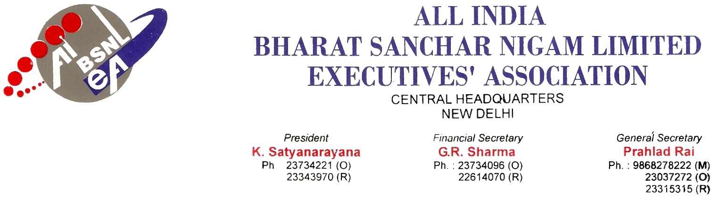
No. AIBSNLEA/CHQ/CMD/2009 DATED 04.02.2010
To,
Shri Kuldeep Goyal
Chairman cum Managing Director
BSNL
NEW DELHI-110001.

Sub: Grant of perks & allowances to Executive of BSNL.

Ref: 1. No. 1-33/2008-PAT (BSNL)/Perks/3 dated 04.09.2009
2. No. 1-33/200/-PAT (BSNL)/Trg. Allowance/1 dated 04.09.2009.

Respected Sir,
In continuation of our letter dated 17.09.2009 we are constraint to draw your kind attention that the order for Granting of Perks and Allowances wherein the revision of Transport Allowance at par with Central Government employees is not granted to BSNL executives.
As an economy measure Transport Allowance may be granted uniformly to all executives instead of providing vehicles, so that BSNL can cut huge expenditure on vehicle/vehicle hiring. 6th CPC had recommended the Transport Allowance at the following rates :

Employees drawing grade pay of | Rate of Transport Allowance per month
In 13 cities classified Other places
as A1/A earlier
Grade pay of Rs.5400 & above | Rs.3200/-+DA Rs.1600+DA
- Grade pay of Rs.4200. Rs.4600 and Rs.4800  - Those drawing grade pay below Rs.4200 but drawing pay in the pay band equal to Rs.7440 & above | Rs.1600+DA Rs.800+DA
Grade pay below 4200 and pay in the pay band below Rs.7440 | Rs.600+DA Rs.400+DA

We request you to decide the rate of Transport Allowance as per the 6th Central Pay commission for Central Government Employees.
The condition contained in Para 3(ii) of O.M. No.21(1)/97 E-II(B) dated 03.10.1997 by which the grant of Transport Allowance to employees provided with official accommodation within one kilometer of office or within a campus housing the place of work and residence was disallowed. This order has been withdrawn by the Central Govt. order dated M.F. (Dept of Expenditure) O.M. no.21(2)/2008-E-II(B), Dt. 29.08.2008. In the same context, we request to you to withdraw the earlier order dated 03.10.1997.
As per the DPE guide lines No. 2(70)/08-DPE (WC) dated 26th November 2008, the company car would be provided to the Directors and CMD. The Executive Directors/General Managers heading the projects of CPSEs may also be provided with the company car. For the purpose of CTC, the expenditure on car provided should be excluded. For others providing of vehicles may be reconsidered as per DPE guide lines by granting Transport Allowance at par with Central Government employees.
Grant of Training Allowance: The 6th CPC recommended to continue the same 15% on revised basic pay. The same has been implemented for Central Government employees. BSNL has diluted this order by granting @ 7.5% on Training Allowance. Hence, a huge amount @ Rs.1500/- monthly will be recovered from 27.02.2009. A heavy financial burden for the executives. Hence we request to you kindly grant 15% on revised basic pay at par with Central Government Employees.
Transfer Grant: Order to be issued as One month basic pay on revised pay.
Encashment of EL (Short fall of 300 days EL): Consequent upon the decisions taken by the Government on the recommendation of the 6th CPC relating to encashment of leave in respect of Central Government employees it is decided in supersession of all orders on the subject both Earned Leave and Half Pay Leave shall be considered for the encashment of leave subject to overall limit of 300 days. The cash equivalent payable for Earned Leave shall continue unchanged. However cash equivalent payable for Half Pay Leave shall be equal to leave salary as admissible for half pay Leave plus Dearness allowances admissible on the leave salary without any reduction being made on account of Pension and Pension equivalent of other retirement benefits payable. To make up the short fall of Earned leave no commutation of Half Pay Leave shall be permissible.
Child care leave: Women employees having minor children may be granted child Care leave by an Authority to grant leave, for a maximum period of two years (i.e. 730days) during their entire service for taking care upto two children whether for rearing or to look after any of their needs like examination, sickness, etc., The officials in BSNL are governed by CCS (Leave) Rules, 1972. Hence the order issued by the DOPT dated 11.09.2008 is also applicable to BSNL officials also.

We would therefore, request you to kindly intervene in the matter so that the Perks Committee recommendations are fully implemented and the PSU executives are not put in disadvantage position in compare to Central Government Employees.
With kind regards,
Yours Sincerely,
Sd/-
(Prahlad Rai)
General Secretary
Copy to:
- Shri Gopal Das, Director (HR), BSNL CO, New Delhi.
- Shri S R Kapoor, ED (Fin), BSNL CO, New Delhi.

