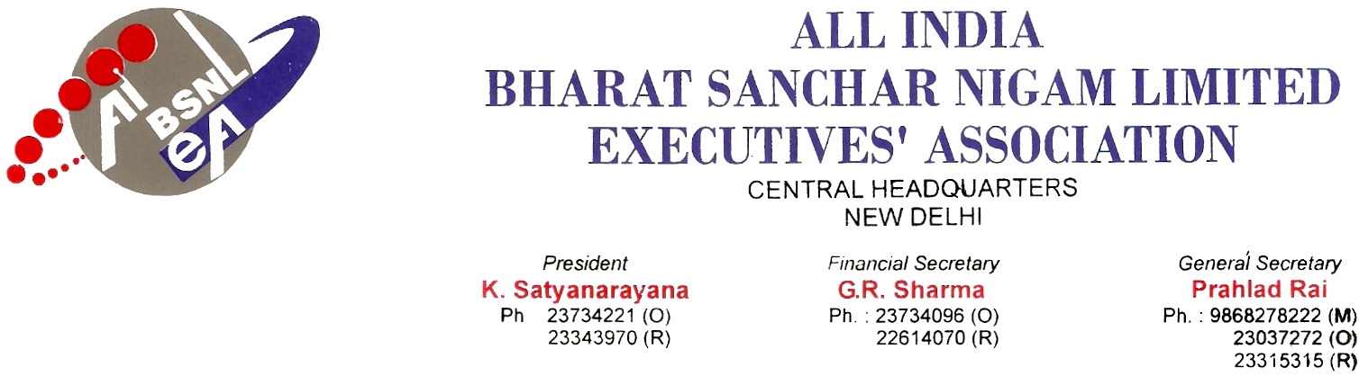

No. AIBSNLEA/CHQ/DOT/2010 Dated: 3rd February, 2010

To
Shri P J Thomas,
Chairman Telecom Commission & Secretary (T),
Department of Telecommunication,
Sanchar Bhawan,
New Delhi 110 001.

Sub: Revision of Pension/family pension of the absorbed BSNL Executives, retired before 01.01.2007 - Reg.

Respected Sir,

We are constraint to bring to your kind notice on the above subject matter for immediate revision of the pension/family pension of the absorbed BSNL Executives who retired between 1.10.2000 and 31.12.2006. They were ensured Government pension on IDA pay scales by making necessary amendment to FR-37A by Government of India. Revision of their pension/family pension, became due following revision of the IDA pay scales of the BSNL executives w.e.f. 1.1.2007. The erst-while employees of DOT/DTS/DTO, on their absorption in BSNL were granted IDA pay scales. Further, in accordance with Rule 37-A of CCS (Pension) Rules 1972, they were granted pension only on IDA.

But, Department of Telecommunication, moved a proposal in 2008 for revision of pension/family pension on CDA pattern based on the OM No 4/14/2001-P&PW(D) dated 19.09.2003 issued by the DOP&PW, revision of pension have been denied with effective from 1.1.2007.

The wage revision of BSNL executives took place w.e.f. 01.01.2007 and accordingly the executives retired thereafter, started getting pension at revised rates from GOI, DOT.

The pension/family pension revision benefit to executives, who retired prior to 01.01.207, has not been extended, as has been done in respect of Central government employees.

It is, therefore, requested that a directive may kindly be issued to get the pension revised of the BSNL Executives retired before 01.01.2007.

With kind regards, Yours Sincerely,
Sd/-
(Prahlad Rai)
General Secretary
Copy to:
1. Shri Chandra Prakash, Member (Services), Telecom Commission, New Delhi..
2. Smt Vijayalakshmi K Gupta, Member (Finance), Telecom Commission New Delhi.
3. Shri Kuldeep Goyal, CMD, BSNL, New Delhi.

