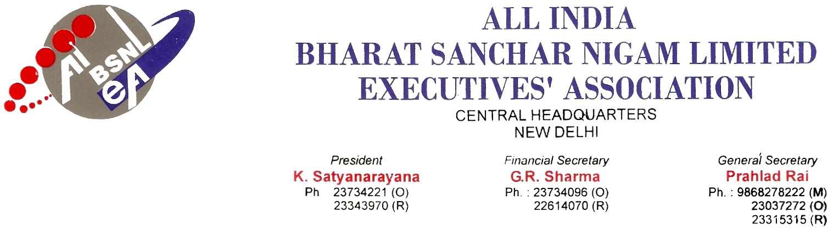
No: AIBSNLEA/CHQ/Dir(HR)/2010 Dated: 1st Feb 2010
To
Shri Kuldeep Goyal
CMD BSNL
New Delhi.110 001

Sub: Change of transfer order from OWN COST to INTEREST OF SERVICE -Reg.

Ref: BSNL’s Employees transfer Policy 6-1/2007-Restg. dated 07.05.2008.

Respected sir,
We are constraint to bring to your kind notice that Pers cell of BSNL Corporate Office is issuing all transfer orders in the cadre of DEs/SDEs at OWN COST even though they have completed two years of service in the circle/station ignoring the BSNL Executives’ transfer policy.
BSNL Executives’ Transfer Policy under General Principle 6 (C) reads, “Request transfers within recruiting unit shall normally be considered after completion of 2 years at a particular station. Transfer after two years on request shall be at company’s cost. If the transfer is due to personal reasons within two years, this will be at the cost of the employee.”
This policy is approved by BSNL Board and with all modifications, order issued vide BSNL CO NO.6-1/2007-Restg. dated 07.05.2008.
Anybody may agree if the request transfers are considered and the order issued before the completion of two years of service in the same Circle/Station at “OWN COST”. But the request for transfer is being considered after two years and the orders are being issued after completion of two years at OWN COST which is against the BSNL’s transfer policy, whereas transfer orders in JAG/SAG/HAG grades after completion of two years are being issued in the interest of service. It is total discrimination between the absorbed and unabsorbed officers in BSNL.
We would therefore request you to kindly intervene in the matter so that all own cost transfer orders issued after completing two years of service in a circle/station are reconsidered and revised in “INTEREST OF SERVICE”.
With kind regards, Yours Sincerely,
Sd/-
(Prahlad Rai) General Secretary
Copy to:

- Shri Gopal Das, Director (HR), BSNL, New Delhi-110001

