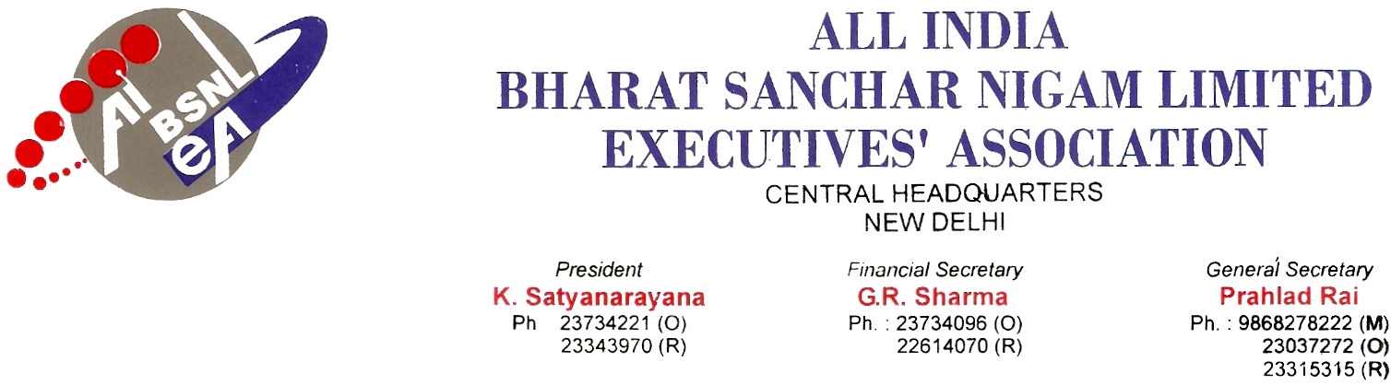

NOTICE

No: AIBSNLEA/CHQ/Office Bearers/NOTICE/2010 Dated 11.02.2010

It is hereby notified that the Central Office Bearers and Advisors meeting of AIBSNLEA will be held at Andhra Association Building, 24-25, Lodhi Institutional Area, Side of Shirdi Sai Baba Temple, New Delhi on 8th and 9th March 2010 to discuss the following agenda :
- Discussion and decision on organizational activities.
- Finalize programme of action and its successful implementation regarding non-settlement of long pending HR issues like Regularisation of STS Group ‘A’ officers working on adhoc basis, Filling-up of all vacant group "A"&"B" posts, Absorption of Group "A" officers, DPC from STS Group ’A’ level executives to DGM , DPC from SDE (T) to DE adhoc , 78.2% IDA fitment benefit and transport allowances , Removal of pay anomaly in case of JTOs recruited in the year 2005, BSNL Management’s decision to procure Swift Desire, Maruti SX4, Honda City for non absorbed officers, Immediate abandonment of BCG etc.
- Discussion and decision on membership verification of majority Executive Association.
- Joint meeting of AIBSNLEA and SNEA, CHQ Office Bearers on 09.03.2010.
- Any other items with the permission of the Chair.
All CHQ Office Bearers and Advisors of AIBSNLEA are requested to attend the meeting.
Note : (1) The boarding and lodging arrangements to the CHQ Office Bearers and Advisors have been made with effect from 08.03.2010 (Morning) to 09.03.2009 (Evening). All the CHQ Office Bearers and Advisors are requested to take the feedback from Circle Secretaries on the agenda items before attending the meeting.
(2) Transit arrangements will be made by Delhi Circle. Contact Nos. are :
- Com. Satish Kumar, CS, Delhi – 09868583030
- Com. Rakesh Sethi, CS, BSNL CO, New Delhi – 09868210449

Sd/-
(Prahlad Rai)
General Secretary
Copy to :
- All the CHQ office bearers, Advisors of AIBSNLEA.
- All the Circle Secretaries/Circle Presidents/CWC members of AIBSNLEA.
- All the Chief General Managers, BSNL.
- CMD BSNL, Director (HR) BSNL & GM (SR) BSNL.

