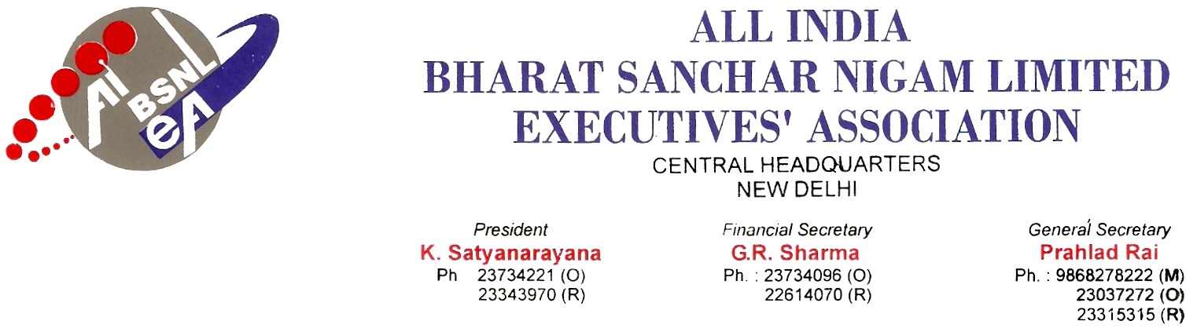

No. AIBSNLEA/CHQ/CMD/2010 DATED 01.02.2010
To,
Shri Kuldeep Goyal
Chairman cum Managing Director
BSNL
NEW DELHI-110001.

Sub: JAO Part II Internal Competitive Exam-Reg.

Respected Sir,

It is to bring to your kind notice that on the above subject matter, candidates had appeared in JAO Part II examination held in March 2006 and some of them got exemption in some papers and some of them could not succeed in the said examination owing to non-awarding of “PROCEDURAL MARKS” as given to other departmental examination.

JAO examination was conducted as per guidelines issued under vide circular no.17-3/2000 SEA-II dated 09.09.2002 as per syllabus forwarded vide SEA branch DOT Ministry of Communications circular No. 17-1/83 SDE 13.02.1985. The JAO Part-II examination is qualifying as per A-2 mentioned in circular No. 17-3/2000 SEA-II dated 09.09.2002. Hence the parameter laid down in circular No.9-32/98-DE dated 30.11.1998 for grace marks is applicable to this examination also.

Therefore we request you to consider the following points as one time measure.

- Kindly relax the qualifying marks into 30 % or
- Regularise all officiating JAOs. Since 10 years they are working as officiating JAO and they have acquired sufficient experience and knowledge to work as full pledged JAOs. Or
- Conduct a special examination to the failed candidates as qualifying marks.

We request you to kindly consider the case favourably and order accordingly.

With kind regards, Yours Sincerely,
Sd/-
(Prahlad Rai) Copy to: Sri S R Kapoor, ED(Fin), BSNL CO,New Delhi General Secretary

