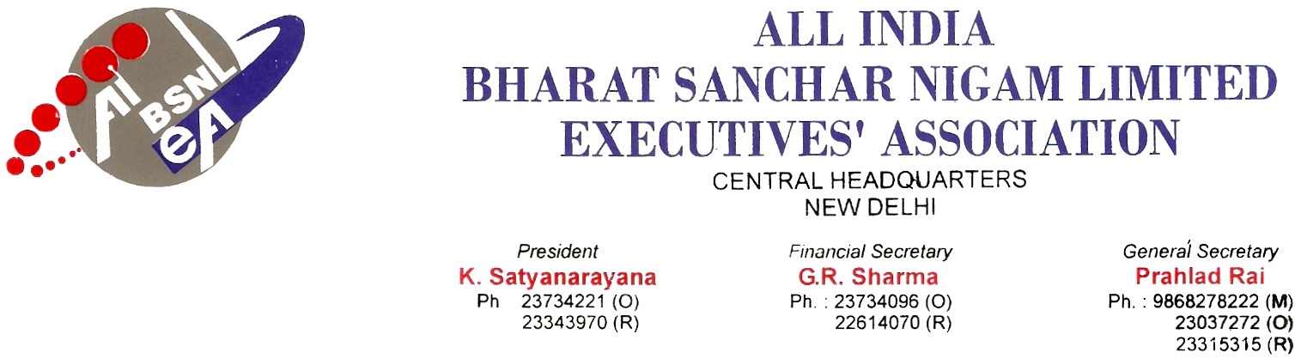
No. : AIBSNLEA/CHQ/CMD/2010 Dated 12.02.2010
To,
Shri Kuldeep Goyal
CMD BSNL
New Delhi-110001

Subject : Huge & unjust expenditure in the Marketing cell-reg

Respected Sir,
We would like to draw your kind attention to the huge and unjust expenditures being made in BSNL’s marketing cell as well as in Telecom Circles. It is reliably learnt that a private firm is directly approaching the BSNL C.O. for granting about Rs. 50 crores for IPL match advertisement which will be for the purpose of display on boundary lines and 3G mobile, which does not divert much attention of public, mainly the players and the ball is watched by the spectators. There are no set norms for the advertisement as to how much expenditure will be made and what will be the profit to the Company.
Merely on a requisition from a private company such a huge amount should not be granted in view of the continues declining of BSNL’s profit. Since such expenditures are being made frequently by BSNL CO, there can’t be check on the Telecom Circles’ expenditures by BSNL Head quarters. It is important to note that under the austerity measures so many operation and maintenance expenditures have been reduced. Similarly the 78.2% IDA fitment benefit, revision of Transport Allowance and Perks etc. have also not been made for BSNL executives and non Executives whereas, such huge and unjust expenditures are being made in a continues manner.
It is therefore, requested to kindly intervene in the matter so that such huge and unjust expenditures are immediately stopped.
With kind regards,
Yours Sincerely,
Sd/-
(Prahlad Rai)
General Secretary
Copy to :
- Shri. J.K. Roy, ED (CA), BSNL C.O., New Delhi
- Shri. S.C.Ahluwalia, GM (Corporate Marketing), BSNL C.O., New Delhi

