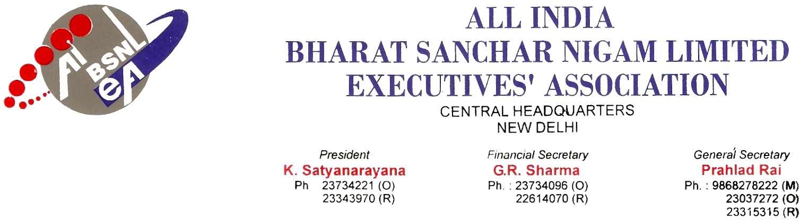

No. : AIBSNLEA/CHQ/CMD/2010 Dated 09.02.2010

To,
Shri Kuldeep Goyal
CMD, BSNL
New Delhi

Subject : Harassing, callous and indifferent attitude of CGM, NCES towards the Executives – reg.

Sir,

We regret to mention that despite of our repeated requests, the harassing, callous and indifferent attitude of CGM NCES towards BSNL executives has not been stopped. CGM NCES in a calculated way is harassing the NCES executives by not granting of conveyance charges on tours, non-settlement of medical claims, no issuance of local officiating promotion orders against vacant Gr. B and STS vacant posts. The instructions / guidelines of BSNL CO on the above issues are not being implemented. NCES executives are seriously frustrated and agitated against non-settlement of the following issues which needs immediate settlement :

Issue I: Denial of Auto fare /Taxi fare for executives of RMC, Chennai

All the executives of RMC ,Chennai who are residing in Chennai U/A have written to the department of Censes Operations, Tamilnadu under RTI act and got reply that their residence falls under Chennai Urban Agglomeration. And the same were submitted to the CGM through the DGM, Chennai. It is learnt that even after seeing those letters; the CGM is not inclined to allow Auto fare / Taxi fare for executives of RMC, Chennai and replies that the staff are living in gram panchayat.

Issue II : Withdrawal of powers for authorization for BSNLMRS indoor treatment for staff in RCES, Chennai unit . The authorization is issued from DELHI NOW
The present CGM NCES has assumed office at New Delhi during February 2006. He issued orders on 30-10-2006 to withdraw powers of DGMs of RCES units to issue authorization for indoor treatment for staff in their units.
In this connection, it may be noted that in Chennai Telephones, DEs are empowered to issue authorization for indoor treatment for staff in their division even though the CGM is headquartered in Chennai itself. The correspondence to New Delhi and back involves lot of man power at both ends and speed post/courier charges in addition to loss of precious time for treatment of the patient.
We request you to arrange for delegation of powers to DE (RMC I) and DE(RRC) of RCES Chennai.

Issue III : For cataract Eye operation ,BSNLMRS authorization is not given in NCES circle. The same is allowed in territorial circle viz. Chennai Telephones and all other circles. And CGHS authorities are issuing Admission memos for admission as in-patients in recognized hospitals for CGHS beneficiaries.
Under RTI queries (1) The director, CGHS, Chennai, (2) the director ,Dr. Agarwal Eye Hospital, Chennai , (3) the GM(O) and CPIO, Chennai telephones and (4) The CPIO, BSNL Corporate Office, New Delhi THAT the CATARACT surgery with IOL implantation is an INDOOR treatment.. The CGM says that the procedure of BSNL C O as well as Chennai Telephones is wrong and also said that no authorizations are being issued for cataract surgery with IOL implantation.

Issue IV : Attaching the RCES unit under Chennai Telephones for the purpose of BSNLMRS and Settlement of Pension at least and more preferably all administrative and accounting activities.
In every pension case we find that there is abnormal delay in settlement of pension claims and payment of terminal benefits. This is because the administrative control is at New Delhi. There is risk of loss of vital document related to the sensitive issue of pension during postal transit. Since the personal interaction is very difficult, the pension settlement is enormously delayed even for small clarification or certificate.
All RTTCs were under administrative control of respective circles whereas they are technically controlled by BRBRAITT, Jabalpur. Still NRC, Mumbai is under administrative control of MTNL whereas technical control is with NCES, New Delhi.

Issue No V : Non Issue of Local Officiating at Circle Level.
Issue No VI : Tenure transfer on long standing basis.
Recently a list has been issued by the corporate office regarding with longstanding list of 20 executives. In NCES circle, there are only 19 executives below the age of 55 years. But none of them is longstanding in this circle. All the 19 names including 9 SDEs in RCES have been submitted to corporate office the name of those who have completed only three years in this circle also included in the longstanding list.
Further since NCES circle is a specialist circle and there is shortage of executives in this circle, for routine transfer in the same cadre or while promoting, kindly see that NCES executives are not disturbed.
We would therefore request you to kindly request you to kindly intervene in the matter so that the above mentioned problems of NCES executives are immediately settled.
With kind regards,
Yours Sincerely,
Sd/-
(Prahlad Rai)
General Secretary
Copy to :
- Shri P.J.Thomas, Secretary (T), DOT, New Delhi
- Shri Gopal Das, Director (HR), BSNL, New Delhi

