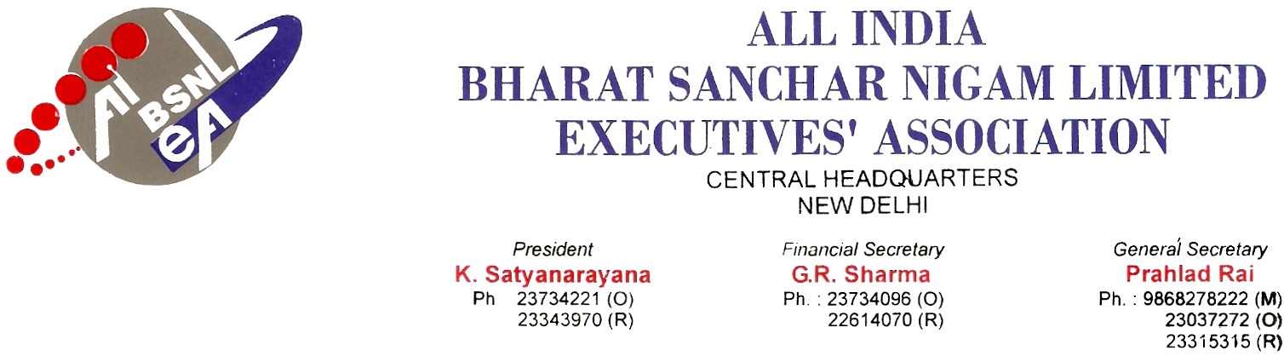

No. AIBSNLEA/CHQ/ED (F)/2010 Dated 09.02.2010

To,
Shri S.R.Kapoor
ED (Fin)
BSNL
New Delhi

Sub. : Relieving of Accounts Officers from WTR, NE-I, NE-II, GUJ & BSNL CO-Reg.

Sir,

We are constraint to bring to your kind notice that WTR, NE-I, NE-II, Gujarat and BSNL Corporate Office are not relieving the Accounts personnel belonging to Tamilnadu Circle. The issue has been discussed informally with GM (FP) but till now remains unsettled. It has caused serious frustration and resentment in the minds of executives. The current status is furnished below :

1. Shri C. Sankarakumar, AO, WTR tfr. Order issued on 17.6.09 -- Not yet relieved. Reason stated by the IFA, WTR is “no substitute posted”. Even after 7 months of transfer order, the relief is not at sight.
2. Shri Radhakrishnan AO WTR not yet relieved citing the same reason. Both (1) and (2) could not get their parent SSA in Tamil nadu Circle due to non-availability of vacancy and posted to nearby SSA where there is shortage.
3. Shri N. Venkatraman, AO CFA Corporate Office -- His relief is a peculiar issue. When the GM SEA and GM CA of Corporate office could able to relieve the 2 AOs working under their control (covered in the same transfer order), GM TR-CFA has not relieved Shri N Venkatraman who was issued transfer order on 17.6.09.
4. & 5. Shri Udhayan and Shri Manivannan are to be relieved from Gujarat Circle.

The above AOs relief 1 and 2 should not be linked till the ensuing rotational transfer orders.

It is therefore requested to kindly intervene in the matter so that above officers are immediately relieved.

With kind regards,
Yours Sincerely,

Sd/-
(Prahlad Rai)
General Secretary

Copy to : GM (FP), BSNL CO, New Delhi

