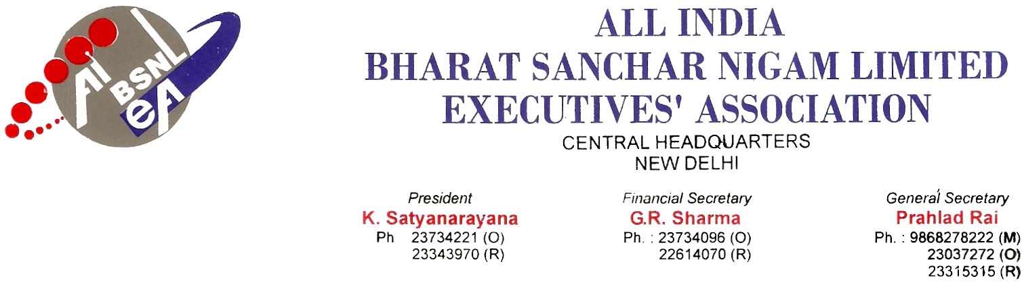
No: AIBSNLEA/CHQ/CMD/2010 Dated 17.02.2010

Shri Kuldeep Goyal
CMD, BSNL
NEW DELHI-110 001

Subject:-Case of regularisation of qualified and trained TTAs now officiating as JTOs-regarding

Respected sir,
This is to bring to your kind notice, a grave injustice being continuing in BSNL to a section of employees (Officiating JTOs) and for speedy settlement of the same, at your earnest sympathy. The applicants are substantive holder of the post of TTA, officiating as JTO in the pay scale of Rs.9850-25-14600 since the year 2005, after completing necessary training to the post JTO and discharging duties of JTO. These officials are standing qualified as JTO on passing the Screening Test conducted in the year 2000 under JTO Recruitment Rule 1996 of DoT. These officials are being denied the regular promotion even after 10 years of passing the promotion examination.
A number of TTAs were qualified in the 35% qualifying exam in 1995 in accordance with RR of 1990. Before all of them got absorbed, the new 1996 RR came into being. At that time the TTAs who qualified earlier to the publication of the rule were given protection ie, "they were deemed to have been qualified in the new 96RR" .Thereafter 1999 RR and subsequent to the formation of BSNL, 2001 RR also came into existence wherein a competitive exam was brought in for the Departmental candidates for the post of JTOs. The Officials who were earlier permitted with various engineering qualifications were restricted and only certain branches like Electrical. Electronics, Telecom, Computer science..etc were permitted to appear in the exam.
Knowingly or unknowingly the people who were qualified in the 1996 RR were not given protection .The following hardships are caused due to the change of RR of 2001 Of the 5500 TTAs qualified and waiting for appointment as JTOs, 3500 got absorbed. The balance 2000 people were sent for training in accordance with 2001 RR syllabus and subsequently appointed to officiate as JTOs in various states of the country and they have been discharging their duties to the satisfaction of their superiors to the best of their ability till date. There have been no instances where they were declared unfit during this period. Most of these people have been working for more than 5 years as JTOs continuously.
Of late, BSNL HQ directed the field units for notification of LDCE in accordance with 2001 RR to fill up the vacant departmental 35% vacancies, wherein it is not clear whether the already qualified TTAs, trained and waiting for regular appointment are to appear for this exam. Besides many of them cannot appear for the exam even though many of them are B Tech in other fields and now working as Officiating JTOs.. All along these years they were qualified, trained and working as JTOs. There was no opportunity given to them for appearing in any competitive exam for any hierarchy and thus denied all promotional avenues and also there was no scope for 16-26 formula for this lot of people.
You may agree with us the enormous amount of mental agony and financial deprivation these people will be subjected to in case of reversion. It will be unthinkable for these lot to again go and work in the lower rank having worked for long time as JTOs .Already all recognized and non recognized unions/associations have approached your good self to amicably settle this issue as a one time measure.
On formation of BSNL an agreement was signed by the management with the staff unions to the effect "that all the employees who have already qualified for promotion will be absorbed before fresh appointments are done". Copy of agreement enclosed. This promise has been violated and many people have been appointed to the post of JTOs.. No protection was given in the 2001 recruitment rule to accommodate these already qualified TTAs and therefore the left out Officiating JTOs (about 2200) could not be appointed.

Therefore in order to comply the agreement and to give relief to the Officiating JTOs an amendment in the RR2001 is necessary .An amendment to the effect that “The TTAs already qualified in accordance with 1966 RR will be deemed to have been qualified under this RR” be incorporated.

After the amendment all the qualified and officiating JTOs be immediately be appointed before conducting any LDCE in the RR. With this proposal we appeal to you not to bury the case under subjudice as court cases may take enormous amount of time, money and energy and loss of person to man the posts.

Hoping for a very early favorable decision.

With kind regards,

Yours sincerely

(PRAHLAD RAI)
General Secretary

Copy to:-

1. Shri Gopal Das, Director (HR), BSNL , New Delhi
2. Shri D.P.De, GM (Estt.) BSNL, New Delhi

